|  |
| --- |
| **NAVRACHANA UNIVERSITY** |
|  |
|  |
| **SCHOOL OF ENGINEERING & TECHNOLOGY** |
|  |
| **BTech-Information Technology** |
|  |
|  |
| **IN-HOUSE PROJECT**  **RECORD**  **(Review Phase -1)** |
|  |
|  |
| **Final Year BTech-IT** |
|  |
| **SEMESTER: 7** |
|  |
|  |
| **COURSE:IN HOUSE PROJECT** |
|  |
| **COURSE CODE:** |
|  |
| **ACADEMIC YEAR: 2022-23 SEMESTER: AUTUMN** |
|  |
| **TEAM ID:23** |
|  |
| **PROJECT NAME: Green Leaf** |
|  |
| **MEMBER IDs & NAMES: Vijay Vaghela (19125059), Gautam Shah (19125060)** |
|  |

**PHASE – 1 BRAINSTORMING AND REQUIREMENT ELICITATION**

Brainstorming is a method design teams use to spawn ideas to solve clearly defined design problems. Brainstorming combines a comfortable, informal approach to problem solving with imaginative thinking. It inspires people to come up with thoughts and ideas. Some of these ideas can be crafted into original, creative solutions to a problem, while others can spur even more ideas. When used during problem solving, brainstorming brings team members' diverse experience into play. It increases the richness of ideas explored.

This is the introductory phase of project and the students will brainstorm their ideas for project through graphical diagrams like concept mapping and requirements elicitation. Based on these two steps, they will state the problem and domain for which they will find a solution.

**TASK 1:**

This concept map is made for the ease if the user to understand the working of the ecommerce website, we have explain by a small diagram of it [1].

(Fig-1:Concept Map)

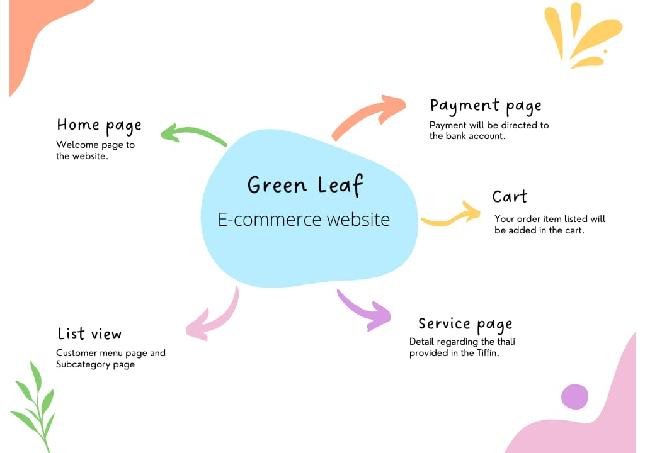

**TASK 2:**

* We will be using a tool that is user friendly and helps us to design and develop a ecommerce website through that we can solve a problem of Tiffin service in an area or locality.
* Problem was to find a Tiffin service man for students and Batchelors. To this problem we have added a solution by making a E-commerce website that will help student and Batchelors to book their orders.

**ACTIONABLE ITEMS**

List of requirements that we will full fill while making a ecommerce website.

* Domain name for the website.
* Mobile friendly.
* Designing part.
* Cart.
* Responsive Layout.
* Payment System.
* 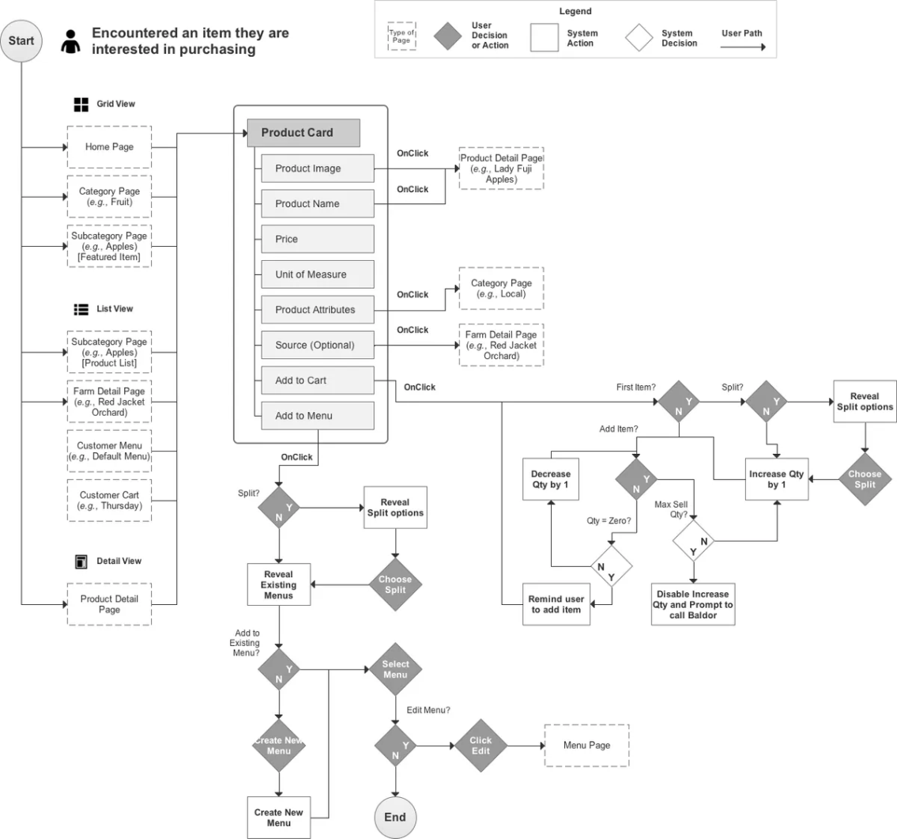

**CONCLUSION**

* To conclude my statement, I would say finding a Tiffin man was a headache to batchers and students, This issue was resolved by providing a solution by making website for booking.

.

**REFERENCES**

**[1]**<https://www.canva.com/>